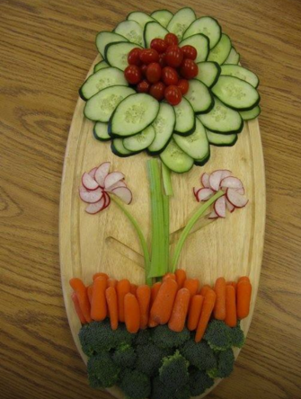
Classroom Party Trays
Introducing the CCS Food Service Classroom Party Tray Packages
Let us help you celebrate!
All packages meet the “All Foods Sold in Schools” requirements.
All orders with payment must be made ten school days prior to date of event.
Please deliver order form to cafeteria or school office.
Tray choices $15.00
Drinks $.20 per serving; choice of 4oz. juice, 8oz. milk plain or flavored or 8oz. bottled water
16” Fresh Vegetable tray - choice of 3; Baby Carrots, Celery, Broccoli, cauliflower, Cherry Tomatoes, Cucumbers with Dip
16” Fresh Fruit Tray- choice of 3; Grapes, strawberries, Apples Slices, Bananas, Orange Slices
Special Name or Age Tray (we will spell your child’s name or age) with cheese cubes, grapes and Pretzels
Pre-Packaged Options: $.50 each
Gold Fish choice of – cinnamon, chocolate, cheddar or pretzel
Animal Crackers, Cupcake – White or Chocolate, Ice Cream Sandwich or Fudge Bar
Muffins – Blueberry, Banana, Chocolate Chip or Apple Cinnamon
Dick and Jane Smart Cookies – States, Presidents or Spanish
Fruit Cups- Diced Pears, Mandarin Oranges, Mixed Fruit, Peach or Pineapple
Strawberry Gogurt or Fresh Baked Cookie; Chocolate Chip, M&M or Carnival

